LESSONS THIS QUARTER
- 02 Mar Proverbs 1:1-19 Seek Wisdom’s Ways
- 09 Mar Proverbs 1:33-3:8 Learn Wisdom’s Benefits
- 16 Mar Proverbs 8:1-9:18 Listen To Wisdom’s Invitation
- 23 Mar Proverbs 10;11;12;17;18;21;25;26;31 Guard Your Speech
- 30 Mar 10;11;13;14;19;20;22;24;26;28;21;27;28 Don’t be a Slacker
- 06 Apr 3;11;13;15;16; 20;21;22;23;28;30 Financial Responsibility
- 13 Apr 3;10;11;13;14;15;16;17;18;19;20;22;25;26;27 Godly Friendships
- 20 Apr Mark 14:32 – 16:8 Amazed by the Resurrection
- 27 Apr Proverbs 20; 23; 29; 31 Avoid Addictions
- 04 May Proverbs 5-6 Moral Purity
- 11 May Proverbs 31:10-31 Treasure Mothers
- 18 May Song of Songs 1:1-5:1 Righteous Romance
- 25 May Song of Songs 5:2-8:14 Invest in the Best

INTRODUCTION
- Our words are vital in creating a safe work environment, a friendly home environment, and a productive society
- Good honest words motivate good behavior and even promote good physical health
- Derogatory words and lies promote physical, mental, and emotional turmoil

Passage | Comments
Proverbs 17:27-28;  21:23 | Think Before Speaking  - 17:27-28. He who restrains his words has knowledge... Even a fool, when he keeps silent, is considered wise;  - Scientists have calculated that men and women think more than 10,000 thoughts a day, and we speak about 16,000 words each day  - That’s 1,000 words each hour, or about 20 words per minute.”  - 21:23. He who guards his mouth and his tongue, guards his soul from troubles.  - If only 1% of our thoughts were impure we would still be in need of a Savior
18:19-21 | Know the Power of Words  - 18:19-21. A brother offended is harder to be won than a strong city… Death and life are in the power of the tongue, and those who love it will eat its fruit.  - With words, God spoke the world into existence
The Dangers of the “Word of Faith” Movement | Also known as prosperity preaching or “name it and claim it” theology, the Word of Faith movement teaches that speaking the right words, in faith of course, forces God to meet our demands.  They falsely twist Scripture to promote earthly health and wealth through faith in one’s words and not faith in God’s word  Our words are, indeed, listened to by God, BUT our words are tied to our heart and attitude, which God weighs before answering appropriately
11:13  26:20-24 | Guard Against Gossip  - 11:13. He who goes about as a talebearer reveals secrets, but he who is trustworthy conceals a matter.  - “Loose Lips Sink Ships” …and churches  - When is it appropriate to divulge someone’s sin? And who should do it?  - 26:20-24. For lack of wood the fire goes out, and where there is no whisperer, contention quiets down... He who hates disguises it with his lips, but he lays up deceit in his heart.  - Freudian Slip: An inadvertent mistake in speech that is said to reveal a person's repressed attitude.  - Sarcasm: A way of speaking in which what is said is the opposite of what is meant
10:18-19;  12:17-19 | Guard Against Falsehood  - 10:18-19. He who conceals hatred has lying lips, and he who spreads slander is a fool. When there are many words, transgression is unavoidable, but he who restrains his lips is wise.  - What is the difference between concealing hatred by lying & concealing a matter out of dignity (Pr 11:13)?  - Watch out for flattery (Pr 20:19; 26:28; 29:5)  - 12:18. There is one who speaks rashly like the thrusts of a sword, but the tongue of the wise brings healing.  - The pen is mightier than the sword, but more have been killed by words than by writing. Words can start wars, and words can stop wars
Other Proverbs on  Healings | - Pr 4:22 For [God’s words] are life unto those that find them, and health to all their flesh.  - Pr 13:17 A wicked messenger falls into mischief: but a faithful ambassador is health.  - Pr 16:24 Pleasant words are as an honeycomb, sweet to the soul, and health to the bones.
25:11-13;  31:8-9 | Use Words to Heal, Not Kill  - 25:11-13. A word fitly spoken is like apples of gold in pictures of silver...  - Part of wisdom is knowing what to say, when to say it, where to say it, how to say it, & when to be quiet  - 31:8-9. Open your mouth for the mute, for the rights of all the unfortunate. Open your mouth, judge righteously, and defend the rights of the afflicted and needy.  - Here is a noble cause for good words, to defend the righteous – but that takes time and energy
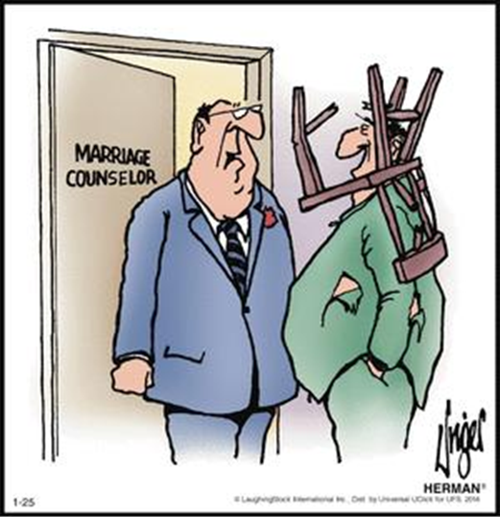
“Sorry to keep you both waiting.
Oh oh, what did you say this time?”

CONCLUSION/APPLICATIONS
- Since we are going to be judged for every word spoken, choose them wisely.

NEXT WEEK: Selected Proverbs. Slothfulness is not next to godliness

